

CSE0001 – Digital Literacy
PROJECT FILE

Name: AADDHYA TIWARI
Registration No: 25BCE11205

TASK 1:- Digital Literacy Awareness Infographic

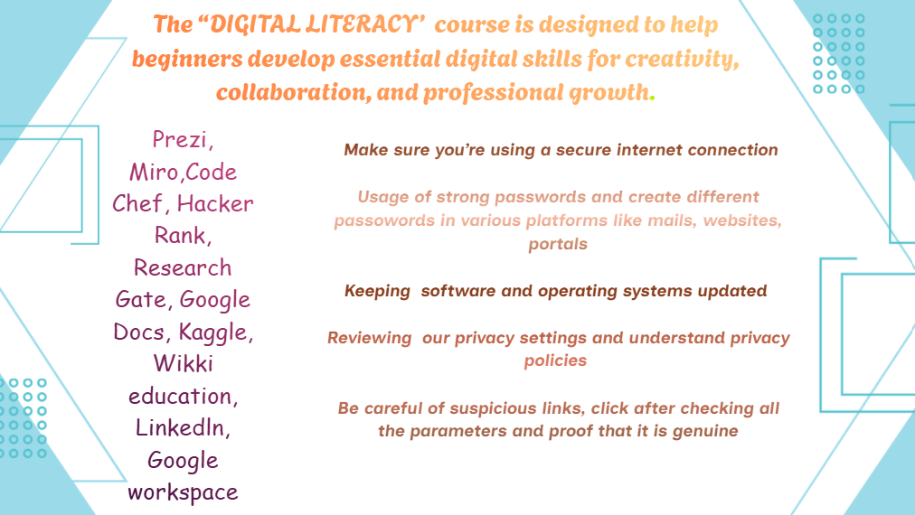
I used Canva presentation tool which is very efficient in making presentations ,videos using ready-made template. It includes gradient colors, contains element section that includes 3-D , shapes, graphics, photos, forms, sheets ,animations ,frames, charts, grids, mockups. We can use variety of fonts and combinations to upgrade our written text and style that attracts the readers.

Many of these are premium text fonts that you need to buy to make use of them. It too has a magic write option in which we can type and it generates
the answer or information which we can directly use in our presentations. We can upload photos of any field like education, business, finance, start up, technology, history and make videos and small ppt’s to showcase knowledge.

Tools help us to beautify presentations by drawing with draw tool, making lines, shapes , and I find sticky notes tool to be the best part of canva as it helps to make short and to the point notes which is pasted in our ppt or reference of a topic. Table tool organize the data.

Projects section collects all your previous and current projects which can be used as per need Magic media generates AI images, videos, graphics, 3-D of what we give description to it.

In the above slide , I have written the definition of digital literacy, furthermore listing out various student digital tools along with internet safety measures to take, as it is necessity to be highly attentive while working on internet.

I found colour platte very interesting as it includes various colours not only solid but also gradient which beautifies the content and seeks attention of the reader.
Task 2: Build Your Student Digital Portfolio

- LinkedIn:

It is a digital platform where we can post profile and get updated in areas of our interests. We make network and connection with people who has same interests as ours. By frequently updating our profile, makes professionals understand that you are into job search, internships or simply connections.
I am planning to post my certificates, achievements so that companies can approach me on the bases of my skills, experience and consistency which the key to success .After each year of B.tech I will increase my connections that I am interested in like entrepreneurship, startups.

2.Research Gate:

Is a networking platform between student and professor, scientists and researcher to share research papers. It increases academic networking and connects to professionals resulting in career development.

I am interested in research work and discovering new fields and concepts. So I next four years I will try to make network with research professionals, building my communication skills so that I confidently present my research papers. This will help me in my PhD.

3.Stack overflow:


Is a collaborative Q&A platform for programmers where user ask questions, write answers, vote on best solutions. Asking genuine and smart questions increases knowledge, writing skills and vocabulary. It is a powerful tool for programmers where my engaging in challenges we can boost coding skills.
I plan to ask doubts relating to coding , AI and computer science, consider and appreciate solutions that resolve my doubt. Be consistent in appearing in challenges and improving my coding skills.

Task 3: Explore Coding & Collaboration Platforms

Part A: CODE CHEF

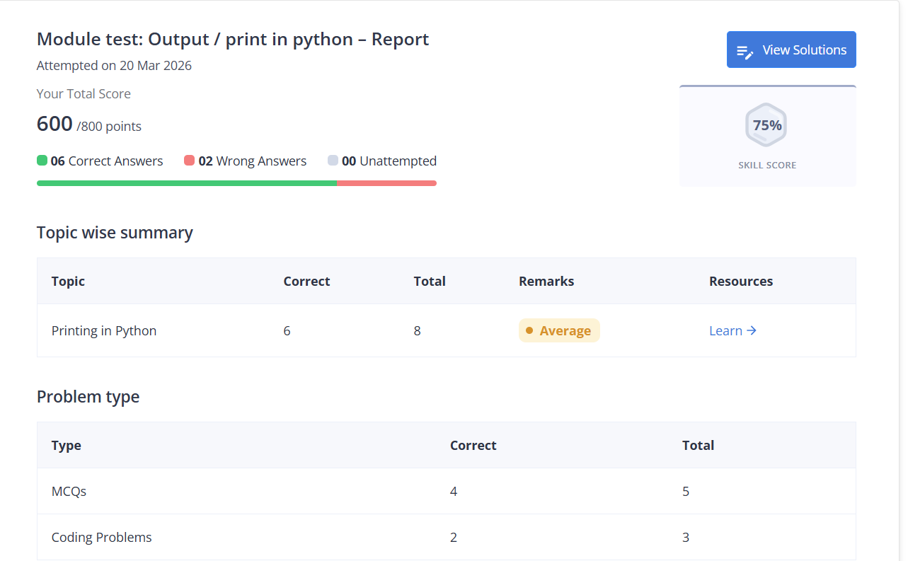
Part B: Google Workspace
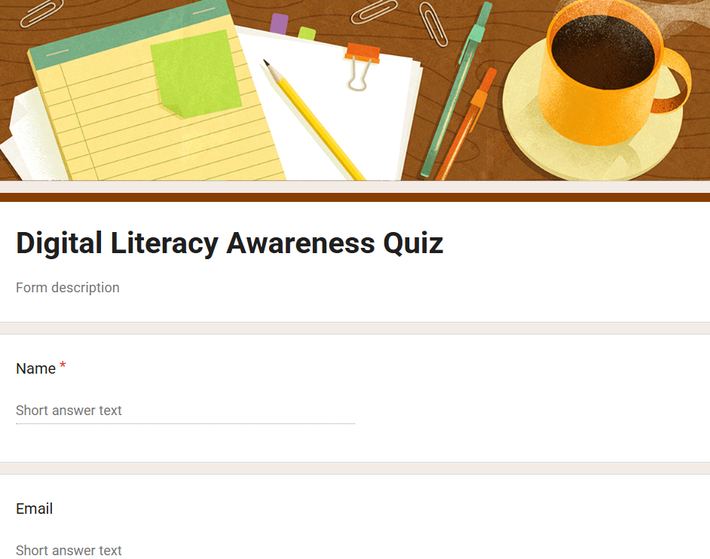
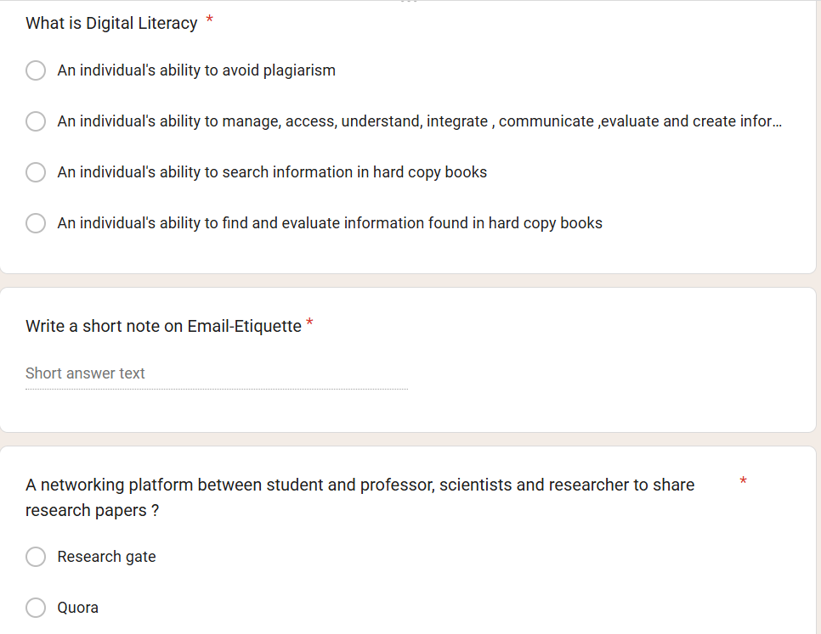
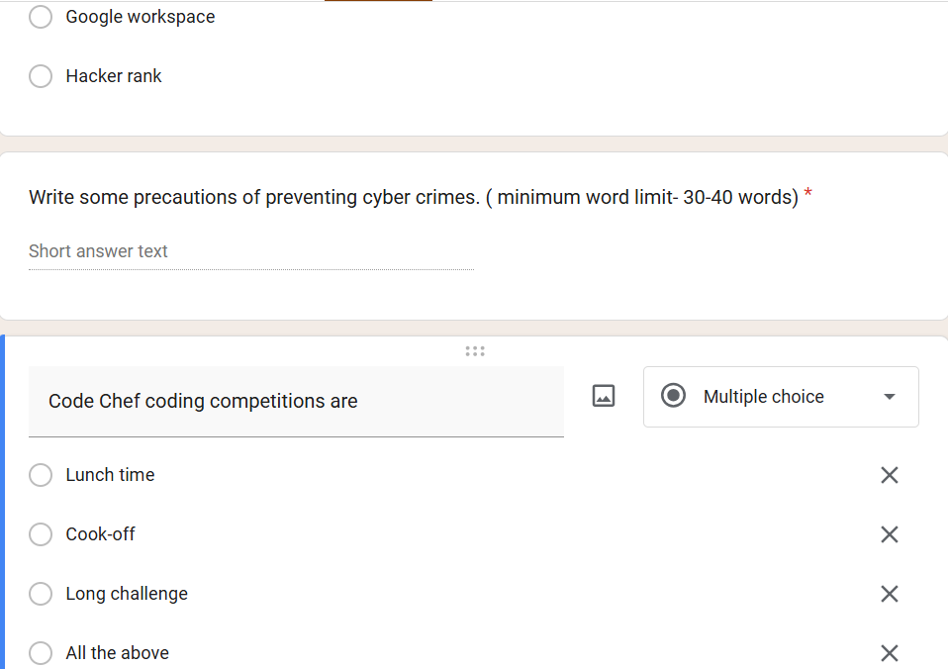

In part -A it was all about using coding platforms/tools to built your coding skills. Is a competitive coding environment created by Unacademy and originally started by Directi. Long challenge, Cook-off and Lunch time are the different stages of coding competitions. I used Code Chef tool in which I was open to learn python language. After attending its online lectures, I practiced its test which includes basic concept of printing the variable, addition of two numbers to making a small program using for / while loop. In academics, this tool is very beneficial as it sharpens your coding skills according to the language you chose. Coding challenges increases your logic and problem solving skills which helps to get the ability to tackle any problem statement.

In part-B, I used Google workplace is a online tool for student, educators, business owner in which g-mail, docs, drive and meet work together in real time from anywhere. It contains google form in which we can design any assessment, voting form, for viewers. It is best for feedback collection and for assignment purposes .I gives option to select variety of customize theme as per the title of the form.
I constructed a Digital Literacy Awareness Quiz which includes 3 multiple chose questions and 2 short answer type. I have selected option of submitting only single response , multiple response accepting option is too available.

Task 4: Draft a Professional Email & Etiquette Guide

Part A:
Email 1 — Write an email from a student to their professor requesting an extension on an assignment submission deadline. The email must follow all professional email rules.

To- achugovind@vitbhopal.ac.in
Subject -Extension on an Assignment Submission Deadline
I Aaddhya Tiwari is a student of your Electrical and Electronics Engineering (EEE) subject evening batch. You have posted an assignment of solving and attaching softcopy of question bank. I request you to kindly extend the deadline of assignment submission as due to network issue I was unable to attach my pdf.

Regards
Aaddhya Tiwari

Email 2 — Write an email from a student to an internship coordinator at a company, expressing interest in a summer internship opportunity.

To- saurabhshukla@1234gmail.com
Subject- Interest in a summer internship at your company
I Aaddhya Tiwari, 20 years old B tech student at Vit Bhopal University express my interest in summer internship at your company scheduled from 4th April,2026 to 20th April,2026.

I am skilled at problem solving and logic in coding. I have mastered Python, HTML, Java. I request you to kindly provide me with the details of internship programme in the most possible time. I shall be a skilled member in summer internship.
Hoping a quick response from your end.

Regards
Aaddhya Tiwari
VIT BHOPAL UNIVERSITY

Part B: Create a Social Media Do's and Don'ts checklist:
Do’s:
- Do Manage Your Privacy Settings: Ensure your social media profiles have strong privacy settings to protect your personal information. Regularly review and update these settings to control who can see your posts and personal details.
- Do Maintain a Positive Online Presence: Your social media profiles can be seen by potential employers, professors, and peers. Share content that reflects well on you and demonstrates your interests, accomplishments, and professionalism.
- Do Promote Campus Events and Activities: Use social media to promote and participate in campus events, clubs, and activities. This can help you stay engaged with the college community and make the most of your college experience.
- Do Support Your Peers: Use social media to support and uplift your peers. Share their achievements, attend their events, and provide encouragement through positive comments and messages.
- Do Balance Your Online and Offline Life: While social media is a valuable tool, it’s important to maintain a healthy balance. Make time for face-to-face interactions and real-life experiences that contribute to your overall well-being.
Don’ts:
- Don’t Post Inappropriate Content: Avoid posting content that could be considered offensive, controversial, or inappropriate. This includes anything related to drugs, alcohol, explicit material, or negative comments about others.
- Don’t Overshare Personal Information: Be cautious about sharing personal details such as your location, phone number, and daily schedule. Oversharing can compromise your safety and privacy.
- Don’t Engage in Online Arguments: Avoid engaging in heated debates or arguments online. These interactions can escalate quickly and leave a negative impression on others. If you must respond, do so respectfully and constructively.
- Don’t Neglect Your Digital Footprint: Everything you post online contributes to your digital footprint. Be mindful of what you share, as it can be difficult to remove content once it’s online.
- Don’t Rely Solely on Social Media for Communication: While social media is convenient, don’t rely on it as your only means of communication. Email, phone calls, and face-to-face conversations are often more effective and professional.
The Columbia Space Shuttle Disaster (2003)
- The Problem: During launch, a piece of foam insulation broke off and struck the shuttle's wing.
- The Digital Breakdown: Engineers suspected damage but needed to communicate the severity to management. An engineer wrote a detailed email regarding the damage, but it was reportedly rambling and included personal commentary at the beginning. Consequently, busy managers and engineers did not properly read or prioritize it.
- The PowerPoint Failure: Engineers later presented a PowerPoint presentation to assess the damage. However, the most critical information—that the mathematical model used was invalid for damage of that magnitude—was buried at the bottom of a slide, leading to the risk being underestimated.
- The Consequence: The failure to clearly communicate the critical safety risk through these digital mediums resulted in the shuttle disintegrating upon re-entry, killing all seven astronauts on board.

Task 5: Cybercrime Awareness Case Study & Prevention Guide
Part A: RANSOMWARE
Ransomware is a type of malware that holds a victim’s sensitive data or device hostage, threatening to keep it locked—or worse—unless the victim pays a ransom to the attacker.
How Ransomware Works?
Step 1. Infection and Distribution Vectors:
- One of these is phishing emails. A malicious email may contain a link to a website hosting a malicious download or an attachment that has downloader functionality built in. If the email recipient falls for the phish, then the ransomware is downloaded and executed on their computer.
- Another popular ransomware infection vector takes advantage of services such as the Remote Desktop Protocol (RDP). With RDP, an attacker who has stolen or guessed an employee’s login credentials can use them to authenticate to and remotely access a computer within the enterprise network. With this access, the attacker can directly download the malware and execute it on the machine under their control.
Step 2. Data Encryption:
After ransomware has gained access to a system, it can begin encrypting its files. Since encryption functionality is built into an operating system, this simply involves accessing files, encrypting them with an attacker-controlled key, and replacing the originals with the encrypted versions.
Most ransomware variants are cautious in their selection of files to encrypt to ensure system stability. Some variants will also take steps to delete backup and shadow copies of files to make recovery without the decryption key more difficult.
Step 3. Ransom Demand:
Once file encryption is complete, the ransomware is prepared to make a ransom demand. Different ransomware variants implement this in numerous ways, but it is not uncommon to have a display background changed to a ransom note or text files placed in each encrypted directory containing the ransom note. Typically, these notes demand a set amount of cryptocurrency in exchange for access to the victim’s files. If the ransom is paid, the ransomware operator will either provide a copy of the private key used to protect the symmetric encryption key or a copy of the symmetric encryption key itself. This information can be entered into a decrypt or program (also provided by the cybercriminal) that can use it to reverse the encryption and restore access to the user’s files.

Types of Ransomware Attacks:
- Double Extortion
- Triple Extortion
- Locker Ransomware
- Crypto Ransomware
- Wiper
- Ransomware as a Service (RaaS)
- Data-Stealing Ransomware

Target Audience of Ransomware:
Here are the three industries that are particularly vulnerable to becoming ransomware targets and victims.

- Healthcare
- In recent times, the healthcare industry has become a top ransomware target. One reason for this surge is rooted in the COVID-19 pandemic. Since healthcare organizations like hospitals and testing centres need to continue operations to treat COVID-19 patients and save lives, they cannot afford to have their systems locked out. Consequently, they are more likely to pay a ransom.
- In 2019 and 2020, many Canadian health organizations were ransomware victims, including three Ontario hospitals, a diagnostic and specialty testing company, and a medical company in Saskatchewan. The Communications Security Establishment (CSE), Canada’s cryptologic agency, warns that cyber threat actors will continue to target hospitals, medical clinics, and other front-line services in Canada and elsewhere in the coming year

- IT
- COVID-19 has forced many organizations globally to shift to remote work models. This has made it easier for attackers to explore IT gaps and find vulnerable ransomware targets. The 2021 Ransomware Threat Report found that between 2019 and 2020, the IT sector saw a 65% increase in ransomware incidents. Considering that IT plays a critical role in ensuring business continuity in every industry, this is a worrying statistic.

- In late 2020, IBM Security X-Force analysed ransomware attacks during the year and found that 41% of these attacks targeted organizations with operational technology (OT) networks.

Manufacturing and Industry
- Industrial control systems (ICS) monitor and control physical equipment in industrial operations. In recent years, cybercriminals have increasingly targeted ICS with ransomware attacks. ICS systems in developed countries are particularly attractive ransomware targets, with such attacks increasing in 2020 by 0.25% in Canada and the U.S. This is because attackers prefer to target industrial organizations operating in economically stable countries that can pay the ransom.

Many other industries are also at risk of ransomware attacks, including:
- Government
- Banking, Financial Services and Insurance (BFSI)
- Education
- Legal
- Public Infrastructure
- Energy and Utilities
What are the consequences of a Ransomware Attack?
- Data
During a ransomware attack, a malicious actor will encrypt numerous files making them, and often the systems that rely on them, unusable. If a ransom is not paid these encrypted files are often permanently locked requiring the organization to regenerate the information, if it can.

- Financial
Ransomware is an unexpected cost and it is expensive. In addition to the loss in revenue an organization may suffer, there are other costs that may be obvious and some that are not. More obvious costs include: the cost of the ransom payment (if paid); the cost to remediate the incident, to include new hardware, software, and incident response services; insurance deductibles; attorney fees and litigation; and public relations.

- Reputation
Suffering a data breach or a ransomware attack can adversely affect the reputation of an organization. Some customers may view a successful attack as an indication of weak security practices, or may be so severely impacted by a service disruption they choose to conduct business elsewhere.
- Revenue
A ransomware attack can severely affect the operating capability of an organization. Even if the organization is well prepared and has functional back-ups, restoring affected systems could take hours. Worse, organizations that were not as prepared, or whose back-ups may have been compromised during the attack, could take days or weeks to return to full operating capacity, meaning their revenues will decline or stop all together while they are recovering.

Part B: Prevention Checklist
1. Protect Personal Information
Never share sensitive details such as home addresses, phone numbers, or passwords on public platforms. Adjust privacy settings on social media to limit who can view personal posts and profiles.
2. Use Strong and Unique Passwords
Create complex passwords that combine letters, numbers, and special characters. Using different passwords for each account reduces the risk of multiple accounts being compromised in a security breach.
3. Recognize and Avoid Scams
Be cautious of emails or messages requesting personal information, especially if they contain urgent language or unfamiliar links. Verify the authenticity of websites before entering login credentials.

4. Report and Block Cyberbullying
If students experience or witness online harassment, they should report it to the platform and seek support from trusted adults and school staff.
- Use Bank-Specific Mobile Apps Only
Always use the official app of your bank. Also, download these apps only from trusted sources like Google Play Store or Apple App Store. Never instal apps from random links sent via SMS or WhatsApp. Remember that fake apps can steal your login details and drain your account. As such, avoid third-party financial apps unless verified
- Never Share Your PIN or OTP
UPI PIN and OTP are confidential credentials meant only for you to authorise transactions. Sharing them, even with someone claiming to be from your bank or a government agency, will inevitably lead to unauthorised access to your account. Fraudsters often use social engineering techniques, such as creating a sense of urgency or fear, to trick you into divulging this information.
- Verifying Transaction Details and Avoiding “Request Money” Scams
A prevalent scam involves fraudsters sending “request money” notifications, hoping you will approve them without careful review. Always scrutinise the details of any transaction, whether you are sending or receiving money, to ensure accuracy and legitimacy. Mis-entering details or blindly approving requests can lead to irreversible financial losses.

- Understanding UPI Eligibility and Key Regulations

Before you can even begin transacting with UPI, there are fundamental eligibility criteria you must meet. These requirements ensure that only legitimate users with valid financial instruments can access the system, contributing to its overall security and integrity. Adhering to the established transaction limits and understanding the regulatory framework provided by bodies like NPCI and RBI are also crucial for responsible UPI usage.

This framework is designed to protect consumers and maintain stability within the digital payment ecosystem, making it essential for every user to be aware of the rules governing their transactions.
National Cyber Crime Portal (cybercrime.gov.in) and Helpline 1930.
I found recognize and avoid scams. If we a become little more while checking out the spam and suspicious emails, messages and what’s app links, we can actually decrease the cyber-crime attacks.
I will adopt a strict policy of never entering my PIN unless I am actively sending money for a purchase I initiated.
- Think Twice on Urgency: Scammers rely on panic to make you ignore red flags.
- Check the Sender: Verify the payment address/name before scanning.
- Enable Alerts: Set up SMS/app alerts for every transaction, large or small.

To conclude, this digital literacy project not only increased our knowledge but made me understood how important is our data and can be easily misused if we don’t think twice before doing whether transactions, posting online in digital platform.
This project made me learn various digital platforms useful for students in this digital era for working smarter and working on their logic and problem -solving abilities. It helped to reflect on my utilization of LinkedIn, google workspace, Quora, Email and its etiquettes in my 4 years of college tenure.

- https://www.checkpoint.com/cyber-hub/threat-prevention/ransomware/
- https://www.axis.bank.in/blogs/safe-banking/upi-safety-tips
- https://www.beekeeper.io/blog/4-historical-communication-failures-prevented-beekeeper/
- linkedin.com
- forms.google.com
- cybercrime.gov.in

